**Capstone Project - The Battle of Neighborhoods**

**Opening Arabic Restaurant in Paris**

**1. Introduction**

**1.1 Background**

Paris is the capital and largest city of France, as well as its cultural, industrial, and financial center. The geographical coordinate of Paris, France are 48.8566969, 2.3514616. Paris received 38 million visitors in 2019, measured by hotel stays. It was ranked as the second most visited travel destination in the world in 2019, after Bangkok and just ahead of London [1]. Therefore, opening a restaurant in Paris will have a big opportunity to be a successful business.

**1.2. Problem**

In this project, I will investigate that if there is any good location in Paris for opening Arabic restaurant and it really values to open one.

**2. Data**

**2.1 Data sources**

To consider the problem we can list the data as below:

* I get the neighborhood data of Paris from Wikipedia [2]
* I use python geocoder library to get geographical coordinates of neighborhoods [3]
* I use **Foursquare API** **venues explore** method to get the venues of given neighborhoods of Paris [4].
* I use **Foursquare API venues method** to get ranks and likes of restaurants by given venue id (depending if there is rating available ) [4].

**A. References:**

* [1] <Wikipedia> <https://en.wikipedia.org/wiki/Paris#Geography>
* [2] <https://en.wikipedia.org/wiki/Category:Districts_of_Paris>
* [3] [Python Geocoder Library](https://geocoder.readthedocs.io/)
* [4] [Foursquare API](https://developer.foursquare.com/)

**2.2 Feature Selection and Data Usage**

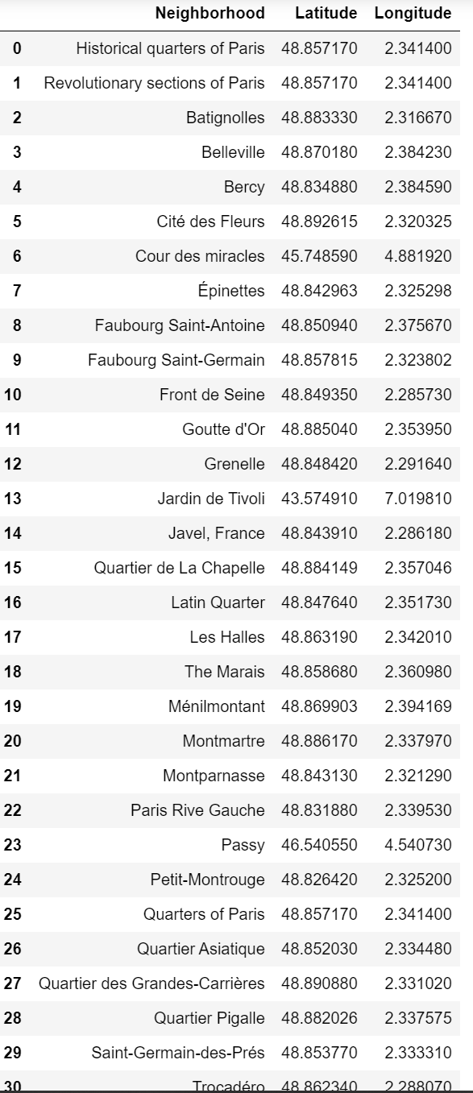I will use neighborhood location values to analyze Paris geographical structure. I will use folium library of python to draw maps by using given latitude and longitudes of neighborhoods. Selected features will be as below

I will also classify neighborhoods by using venues distribution and counts. In this way, I will find similarities of neighborhoods which will help me to choose location for opening a new restaurant. Similar structured neighborhoods may handle same type of venue.

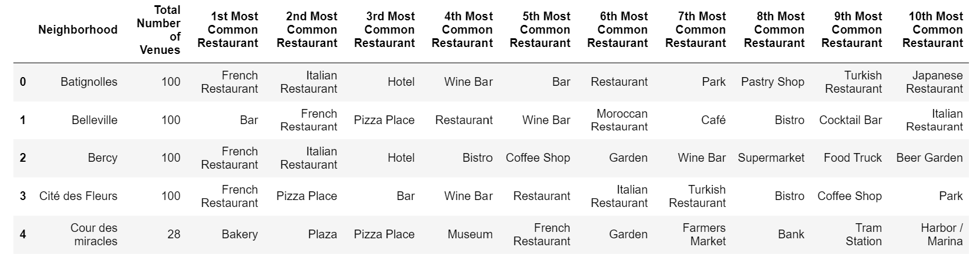

I will use venue list category to find distribution of restaurants and Arabic restaurants in neighborhoods.

